The Secured Door System based on Raspberry Pi using mobile application.

Mohammad Abul Hossain
Division of Computer engineering
Dongseo university
Busan, South Korea
akash21cent@gmail.com

Dae-Ki Kang
Division of Computer Engineering
Dongseo university
Busan,South korea
dkkang@dongseo.ac.kr

Abstract: In recent years, most of the people are interested to use a modern and latest secured device to secure their door system. In this perspective, a new door security device called Bangladesh Security System-2019 (BDSS-19) has been introduced. So, in this entire paper, the product will be described that has been produced using Raspberry Pi. Raspberry Pi plays a role as a mini computer to operate the whole security system. The users can lock and unlock the door in two ways. In BDSS-19, python script detects the opening signal through a magnetic sensor, and then a notification will be sent to the user’s mobile phone. There already exist various similar devices in the present era. But a unique advantage of the proposed system is sending a notification to the user that will ensure every update of the door in 24/7. That means the user is connected to the door always. The system will provide one-way verification. Further information and explanation of the BDSS-19 will be mentioned in details step by step.

Keywords: Raspberry Pi, BDSS-19, magnetic sensor, secured door, notification.

- INTRODUCTION
Nowadays, people are getting more conscious on security especially home and office door security. Technology is the most trusted medium to the people in every perspective. It is also being developed rapidly. Therefore, people fully depend on modern technology to ensure their security as well as door security also. A lot of devices and systems are designed to secure door locking and unlocking system using IOT, Raspberry PI, Mobile Application, Computer and so many technologies. Internet is used to conduct these systems to make the system convenience to the users. These systems play a vital role to ensure door security with less human effort. In order to secure a door, different technology is being designed and developed in the present era.

The project, Bangladesh Security System -2019 (BDSS-19), also will focus on door security using smart phone application, which will confirm door security by notification to users. The system is designed based on Raspberry Pi and magnetic sensor to detect any person entering to the door. The user can lock and unlock the door using mobile application. While a person attempts to open the door, the magnetic sensor will detect anyone’s presence. Then, it will send the signal to operating system, raspberry pi, and instantly the system will notify the user through notification. To conduct the whole system, internet is required for both of Raspberry Pi and user end.

- RELATED WORK DONE
In this modern era, plenty of security projects are being designed, developed and upgraded those are based on door security like BDSS-19. In this section, some of the projects, those are based on door security, will be mentioned in the following:
Gyanendra K Verma and Pawan Tripathi have designed a project on digital door lock security in 201 using RFID (Radio Frequency Identification). It can detect asset tracking, people tracking inventory detection, access control, etc [3]. The main advantage of using RFID is that it performs without a battery and passive tags are lighter and are less expensive than the active one. A user can enter the home using his/her tag in contact with the reader. In this way, the system records all of the check-in and check-out information. But it is very expensive to use. Our BDSS-19 is cheaper than this project. Ours will notify the information of door lock and unlock information.
In 2015, Ilkyu Ha has introduced a project on security and usability of a digital door lock system using IOT (Internet of Things). The system transfers recorded images t a user’s mobile application when an invalid user tries to enter illegally [4]. It also checks access information and operates remotely to lock and unlock like BDSS-19.
Based on a mobile application using Jaro Winkler Algorithm, Sura Mahmood Abdullah has proposed a system in 2016. Here, Jaro Winkler Algorithm is used to compare password to get confirmed. The system also sends and receives information using mobile through Bluetooth within a short range [5]. Where BDSS-19 can send and receive notification from any part of the world if connected to the internet.
In 2013, Md. Nasimuzzaman Chowdhury, Md. Shiblee Nooman, Srijon Sarker together has designed a system based on RASPBERRY PI and internet of things. The system mainly can collect the visitor’s image and send to users and user can reply to the message what will show on the system screen to show the visitor. The user can control the door lock using the internet [6].
Ushie James Ogri, Donatus Manang Bassey Okwong, Akaiso Etim in 2013 has designed a door security system using GSM network based on mobile [7]. But it is not so sustainable and convenience. BDSS-19 is more secure and efficient than this system. BDSS-19 is also based on mobile application but it supports different types of internet service not only GSM network. From this perspective, it is clear that our proposed system called BSS-19 is more secure and efficient than this system. It also can be said that the system is more convenient than this system. So it can be said that BDSS-19 is a user-friendly system.

- RASPBERRY PI
Raspberry Pi is a credit card sized minicomputer board which is connected a LCD, a keyboard and a mouse. It operates like a computer. It has different parts like a computer such as RAM, Hard Drive (SD Card) Audio and Video ports, USB port, HDMI port and Ethernet port. It has different types of operating system like Raspbian, Pidora and NOOBS which are Linux based. It has command line interface only. Using this device, any kinds of operation like audio, video, internet browsing and word sheet processing and so on. The purpose is to develop the design is lower cost and small size. Two types of Raspberry Pi is available Model A and Model B. Model B is the latest and upgrade version of the device. It has 512 MB RAM, 16GB SD Card. Maximum 32 GB SD Card can be set up with the device [1]. There is a USB hub to use charger and USB cable to connect to CPU. Raspberry Pi uses Ethernet connection for internet.

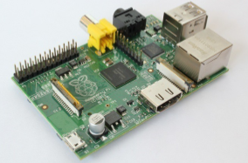

Figure 1. Raspberry Pi 3.

- REQUIRMENT ANALYSIS
The use case diagram shown below describes the system how the user can execute and use BDSS-19 for the secured door system based on Raspberry Pi using mobile application. It is a mobile application based security system. According to our use case, only authorized users, who are registered in this system, can use BDSS-19 which will be operated by Raspberry Pi. Nobody is allowed to use the system and open the door without access permission from the user. If anyone, who are registered in this system, tries to access to the door, he/she cannot access. The user will receive a notification about door security from BDSS-19. In this part, we will discuss the requirement for the system and how the system works.
BDSS-19 is made of Raspberry Pi, magnetic sensor, Android phone and application. We have used python as a programming language.

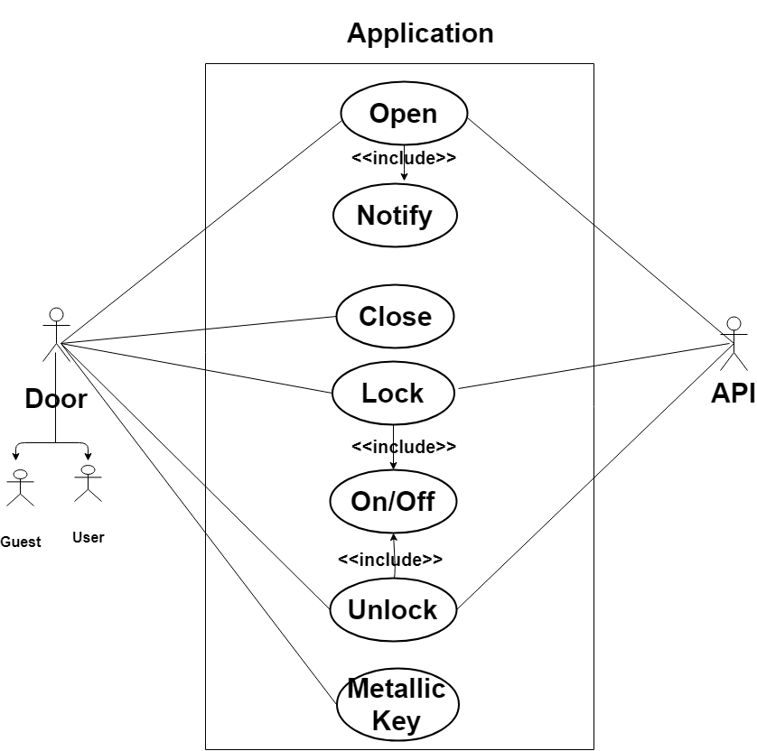

Figure 2: Use Case Diagram
In the following, you can see Use case scenario for DBSS-19 system.

1. The user unlocks the door by using mobile application.
2. If user would like to opens the door then, <<scenario1>>.
4 If User would like to receive email notification then,
<< scenario2>>.
5. The user locks the door by using mobile application.
6. If mobile app does not work then <<secnario3>>.

Use case scenario.
Scenario 1: A user will send a request to the server to unlock the door through URL. The server will send the request to Raspberry Pi and will verify the request through BDSS-19 program, whether the service is available or not. If valid, the door will be unlocked.

Scenario 2: While the door will be unlocked, sensor detector will detect and send a signal to BDSS-19. After that the system will send a notification to the user mobile application.

Scenario 3: If the system is disabled due to internet or electricity or anything, a user can lock and unlock the door manually using metallic key.

In the following, you can see a sequence diagram for understanding how BDSS-19 works step by step.

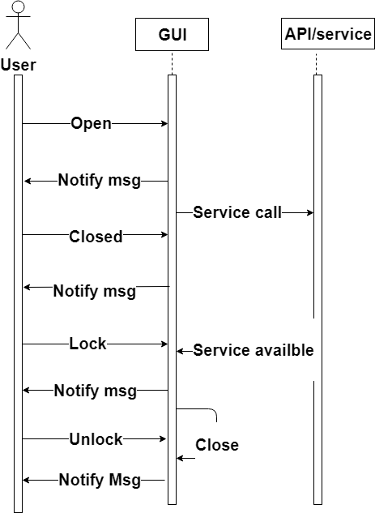

Figure 3. Sequence Diagram

Step1. How to unlock the door through Android application:

- A user will send a request to the system server to unlock the door through URL.
- The server will send the request to Raspberry Pi.
- Raspberry Pi will verify the request through python BDSS-19 program that user account is weather valid or not and service is weather available or not.
- If valid, Raspberry Pi will send signal to motion detector port to unlock the door and the door will be unlocked.
- Thereafter, the system will delay for 10 seconds and then Pushover API will get a request to send notification to the user [2].
- Thereafter, the API will create a token/key for the user.
- Then, user email addressed will be pushed up according to the token/key and a build message will be sent to the email address.
Step2. How to lock the door using Android application:

- A user will send a request to the system server to lock the door through URL.
- The server will send the request to Raspberry Pi.
- Raspberry will verify the request through python BDSS-19 program that user account is valid or not and service is available or not.
- If valid, Raspberry Pi will send signal to motion detector port to lock the door and the door will be locked.
Running example: David is the registered user of BDSS-19. He uses BDSS-19. He reviews the system 5.0 out 5.0. Because, our system ensures proper security for a door, since it provides update to the user 24 hours in a day. He says, BDSS-19 provides expected security for a door within a lower budget. If due to any unexpected reason like internet or electricity problem, system does not work properly, he can use metallic key. Metallic key is manual lock which provides extra security.

- RESULT AND DESIGN
The system has been designed what does work with Raspberry Pi. The system called BDSS-19 provides highest security for home and office door security. We have achieved a pleasant success designing and developing the system. The system holds different functionalities such mobile application, metallic key, internet of things, sending and receiving notification, remote lock and unlocks using mobile application. Raspberry will operate the whole system. Python is used as a programming language to send notification to mobile application from system to users in the Linux operating system. Finally we get advantages from the system

- Provide clear knowledge on security system so that users can understand in details about communication among all Devices and interactions between users or owner and the Internet of things through the system.

- Lock and unlock facilities using mobile application from remote area.

- Send and receive notification from the system, if door is opened. Lock and unlock using metallic key manually.

- Design and increase the door security levels using 3 functions. Introduce new and secured system to the user to ensure security for their door.

- Provide accurate and exact information with time and date of opening the door instantly using mobile application from raspberry pi.

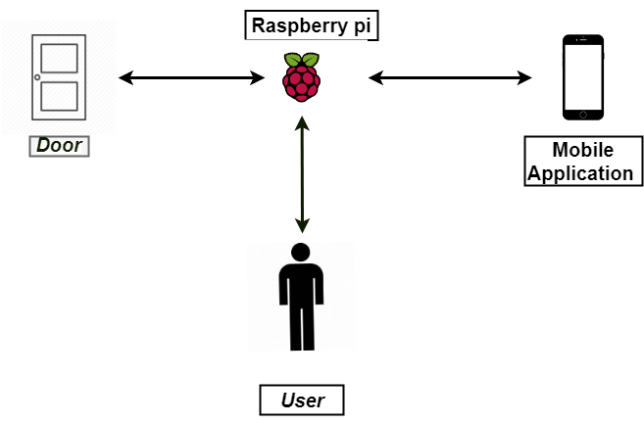

Figure 4: Demo figure of the proposed system.

The following diagram describes the demo version of the proposed product BDSS-19. In the demo, it is shown that there is Raspberry Pi, which plays a role as an operating system. The whole system will be conducted by the Raspberry Pi. Another element is the door which is provided security the system BDSS-19. A magnetic sensor is attached to the door which will send a signal of the door opening. A mobile application which is another part of the system and it is used to lock and unlock the door. Besides, this application also receives notification of door opening. The notification is sent from the Raspberry Pi system. Last but not least element is the user himself/herself, for whom the device and system are designed.
This section will cover the class diagram of the whole system. This section will provide clear and vast knowledge about how to design internal programming.

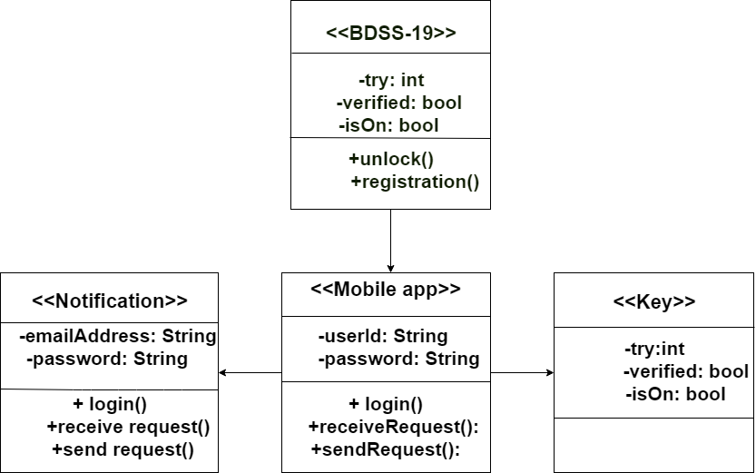

Figure 5. Class Diagram of the System.

The above-mentioned diagram is a design of programming part of BDSS-19. According to the class diagram, it clear that all classes and methods interact with each other. Due to a security issue, all the variables are declared as a private. For each function, an individual class is designed. It is importantly mentioned that Raspberry Pi needs to get connected to the network always as well as Android application.

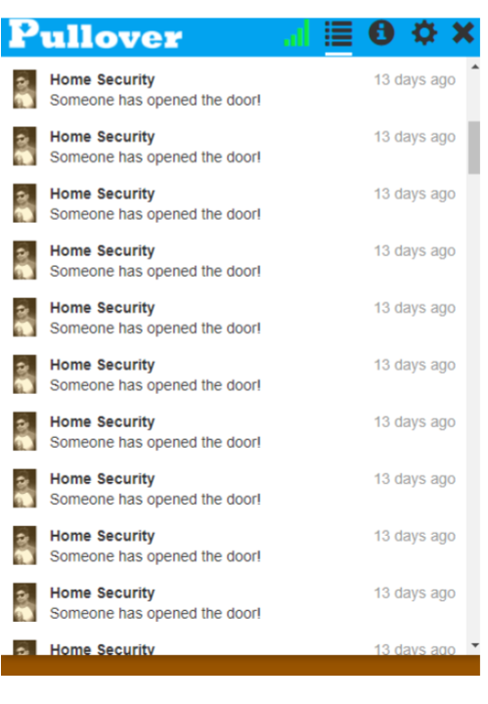

Figure 6. Sample of receiving Notification.

Above mentioned sample is a demo version of receiving notification on Android mobile phone. Another demo version of computer screen is mentioned below. It is how the computer shows results and sends notification to the user’s mobile phone.
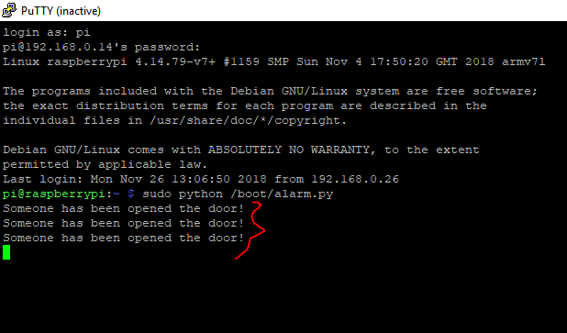

Figure 7: Sending of notification

VII. CONCLUSION AND FUTURE STUDY

The principal goal of BDSS-19 is to ensure the proper security for a home or office door. It is said that nothing is the last and final solution. So, it does not ensure 100% security but as much as possible. To improve security level, remote access through a mobile application is set up to get an updated status of the system door always. It will increase the security level much more. BDSS-19 is providing the latest security technology for the proper security of a door.
However, BDSS-19 is going to represent Raspberry Pi on the field of door security to ensure reliable security. Besides, it is easier to use and it costs lower than any other security system that is based on IOT and modern technology. Since knowledge of technology and computer is almost known to the people, almost all people can use the system. Proper opportunity is required to show the reliability, usability, and effectiveness of the BDSS-19.
Finally, it can be said that the main contribution of the system is to introduce the potentiality of raspberry pi in terms of security. It also is to be highlighted the capabilities of BDSS- 19 which is made based on raspberry pi. Besides, to introduce a new type of security element in the security industry, BDSS-19 will play a vital role. On the other hand, the system continuously has to be analyzed, updated and added different functionalities and technology to take it always up to date. From our point of view, BDSS-19 has no downsides. It ensures the user expected level of security for the home and office door.
The system, BDSS-19 has been designed and developed to provide security on the door system. It is a security system which will provide different services for door security in an easier way and it will increase the level of security undoubtedly. It has different functionalities to lock and unlock and to provide security of a door. In this system, an Android application is designed to send a request to lock and unlock the door. Besides, the application will receive notification from the server of opening the door. The system will be conducted by a Raspberry Pi. Raspberry Pi plays an important role as a mini computer and server. A magnetic sensor will be attached to the door to transfer lock and unlock signal. Based on the signal, the door opening notification will be sent to the user application. Besides, a metallic door lock is also available for extra security. In order to develop the system, python has been used as a programming language. Most importantly, the internet is required to conduct the entire system. If the internet is connected to mobile and Raspberry Pi, the user will receive notification about door security from any part in the world. Every component of the system works simultaneously to make the system successful.
In future, more functionalities and features can be added to the system to make it more users friendly. For instance, Iris recognition, fingerprint recognition, touches keypad for password input, streaming camera for recording the face that will enter the home or office. All the functionalities can be conducted by mobile application, since mobile application also will be developed. So that the system, BDSS-19, gets more convenience and efficient to the users.

REFERENCE
[1] S. Zafar and A. Carranza, “Motion Detecting Camera Security System with Email Notifications and Live Streaming Using Raspberry Pi,” New York City College of Technology, NY, 2014.
[2]Available from: https://play.google.com/store/apps/details?id=net.superblock.pushover
[3] Verma, Gyanendra K and Tripathi, Pawan, “A Digital Security System with Door Lock System Using RFID Technology”, International Journal of Computer Applications (0975 – 8887) Volume 5– No.11, August 2010.
[4] Ha, Ilkyu, Security and Usability Improvement on a Digital Door Lock System based on Internet of Things, International Journal of Security and its Applications 9(8):45-54 · August 2015.
[5] Sura, Mahmood and Abdullah, Design Secured Smart Door Lock Based on Jaro Winkler Algorithm, January 2016.
[5] Chowdhury, Md. Nasimuzzaman, Nooman, Md. Shiblee, Sarker, Srijon, Access Control of Door and Home Security by Raspberry Pi Through Internet, International Journal of Scientific & Engineering Research, Volume 4, Issue 11,November-2013.
[7] Ushie, Ogri James, Bassey, Donatus Enang and Etim, Akaiso, Design and Construction of Door Locking Security System using GSM, International Journal of Advanced Trends in Computer Science and Engineering 2(7):2235-2257 · July 2013.

